**EXPERIMENT NO. 4**

|  |
| --- |
| **Student Name and Roll Number: Avtar Singh - 20csu241** |
| **Semester /Section: 5th /FSB** |
| **Link to Code:** |
| **Date:** |
| **Faculty Signature:** |
| **Marks:** |

|  |
| --- |
| **Objective:**  To write the shell programming code for the following. |
| **Outcome:**  Student is able to write code in shell programming |
| **Problem Statement:**  a) Write a shell program to check whether a number is even or odd  b) Write a shell program to find whether a number is prime or not.  c) Write a shell program to find whether a number is palindrome or not.  d) Write a shell program to type number 1 to 7 and then print its corresponding day of week |
| **Background Study:**  A shell script is a file with a set of commands in it. The shell reads this file and executes the instructions as if they were input directly on the command line.  A shell is a command-line interpreter and operations such as file manipulation, program execution and text printing is performed by shell script. So, we will use vi editor to edit our files. |
| **Question Bank:**   1. What are Zoombie Process?   On Unix and Unix-like computer operating systems, a zombie process or defunct process is a process that has completed execution (via the exit system call) but still has an entry in the process table: it is a process in the "Terminated state".   1. What are different types of variables used in shell script?   Two types of variables can be used in shell programming: Scalar variables. Array variables.   1. What are the different types of modes available in Vi editor? 2. Command Mode 3. Insert Mode 4. Escape Mode 5. What are the different types of permission at file level in shell?   1)Owner Permission  2)Group Permission  3)Other (World) Permission   1. How to use comments in shell script. # |

**Student Work Area**

**Algorithm/Flowchart/Code/Sample output**

a) Write a shell program to check whether a number is even or odd

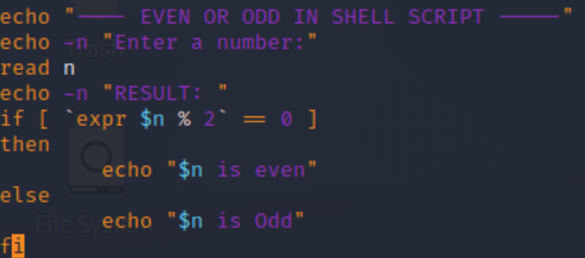

b) Write a shell program to find whether a number is prime or not.

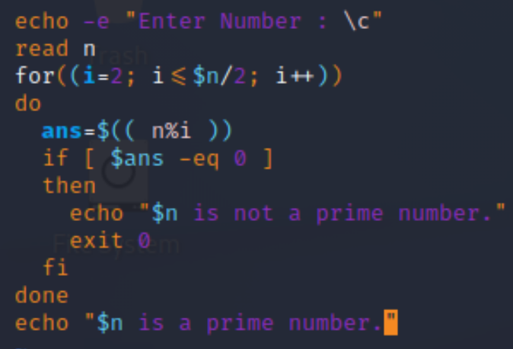

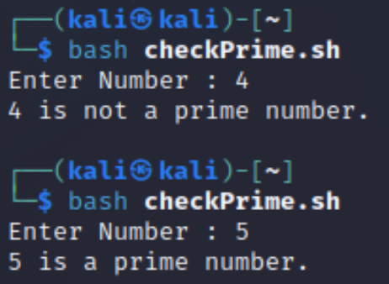

c)Write a shell program to find whether a number is palindrome or not.

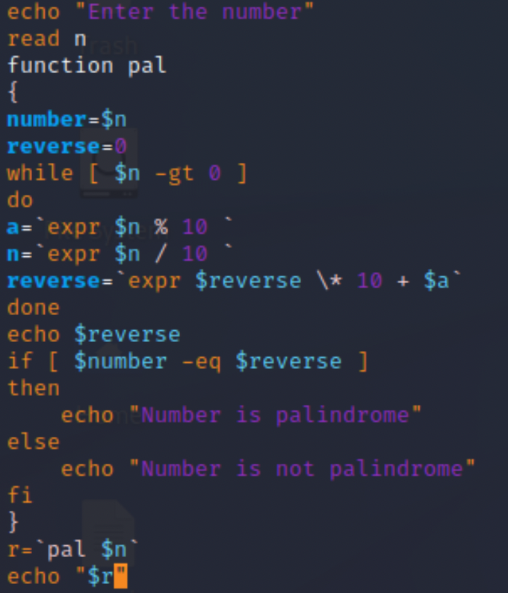

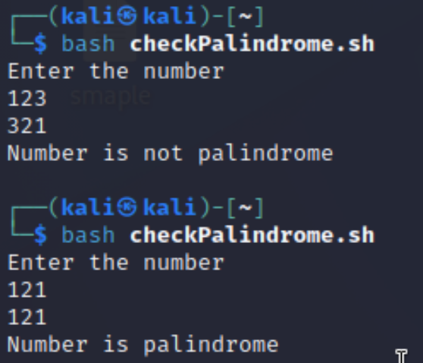

d) Write a shell program to type number 1 to 7 and then print its corresponding day of week

